Digital Speech Processing and Noise Reduction
10.1 Implementation of Spectral Subtraction for Speech Noise Reduction

Program (MATLAB Code)
clc; clear; close all;
Fs=8000; t=0:1/Fs:3;
x=sin(2*pi*200*t)+0.5*sin(2*pi*400*t); % Clean signal
xn=x+0.3*randn(size(x)); % Noisy signal
Y=fft(xn);
N=fft(0.3*randn(size(x)));
xe=real(ifft(max(abs(Y)-abs(N),0).*exp(1j*angle(Y))));
% Signals
figure;
subplot(311),plot(t,x),title('Clean Speech')
subplot(312),plot(t,xn),title('Noisy Speech')
subplot(313),plot(t,xe),title('Enhanced Speech')
% Spectrograms
figure;
subplot(311),spectrogram(x),title('Clean Spectrogram')
subplot(312),spectrogram(xn),title('Noisy Spectrogram')
subplot(313),spectrogram(xe),title('Enhanced Spectrogram')
% Magnitude Spectra
figure;
subplot(311),plot(abs(fft(x))),title('Clean Spectrum')
subplot(312),plot(abs(fft(xn))),title('Noisy Spectrum')
subplot(313),plot(abs(fft(xe))),title('Enhanced Spectrum')

Output

Fig 1
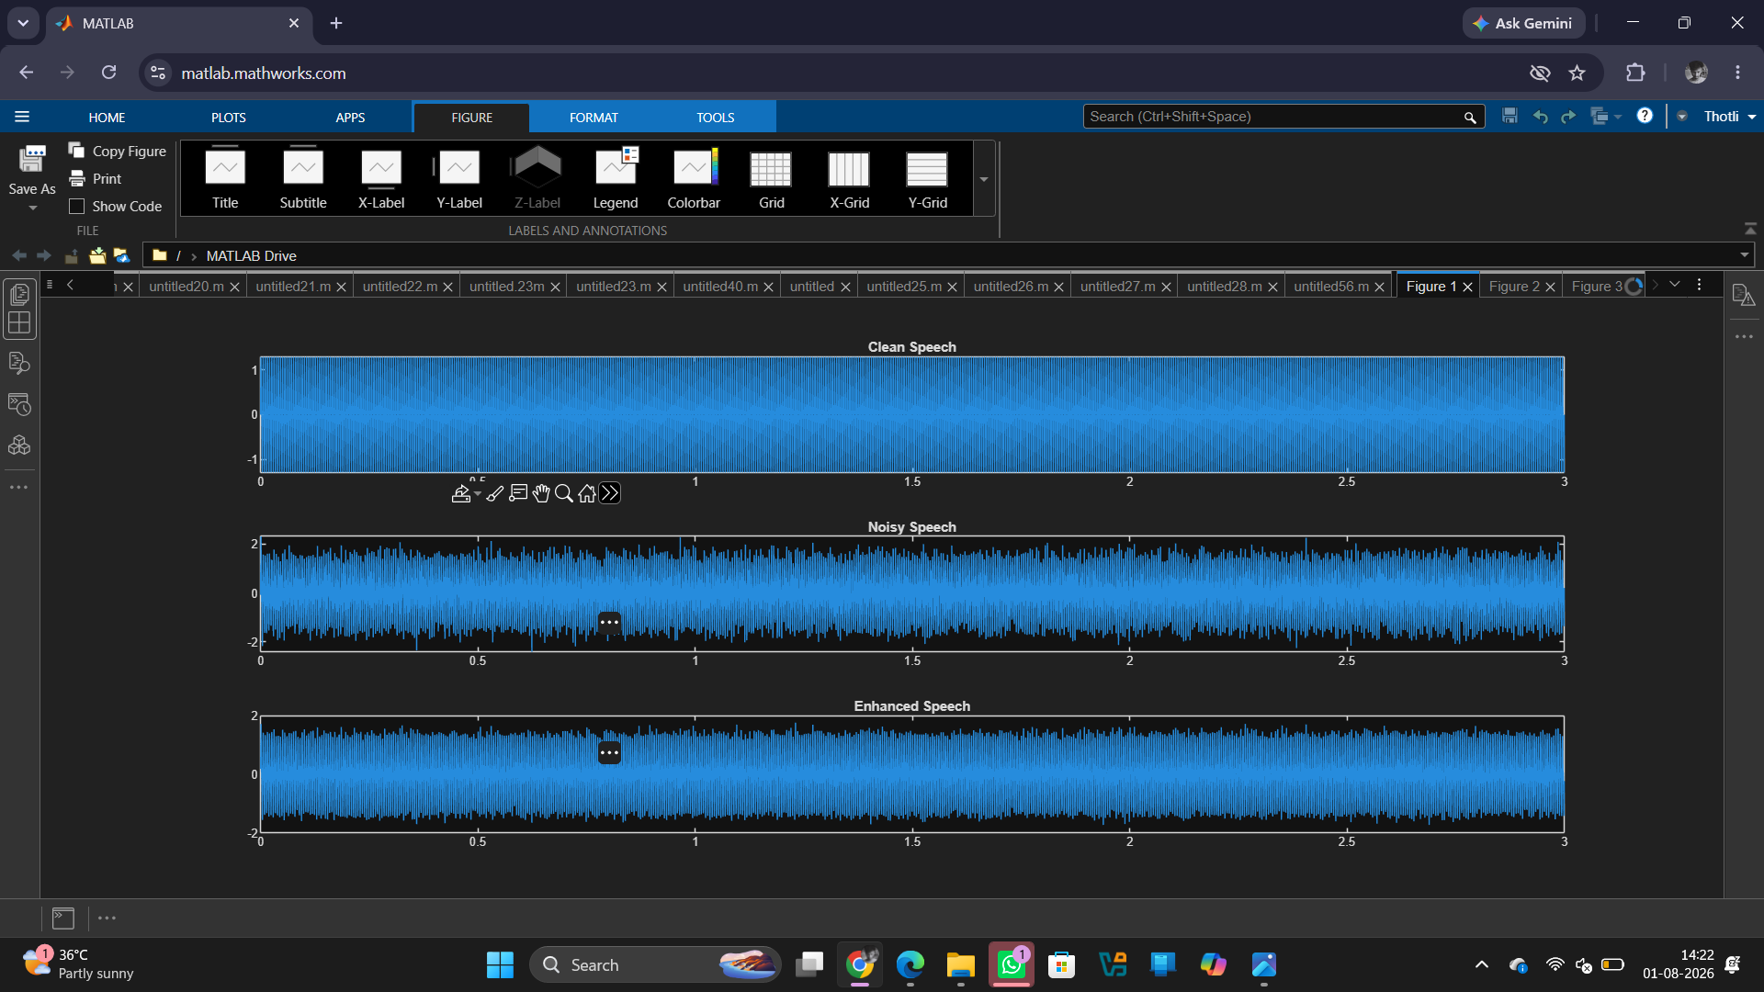

Fig 2
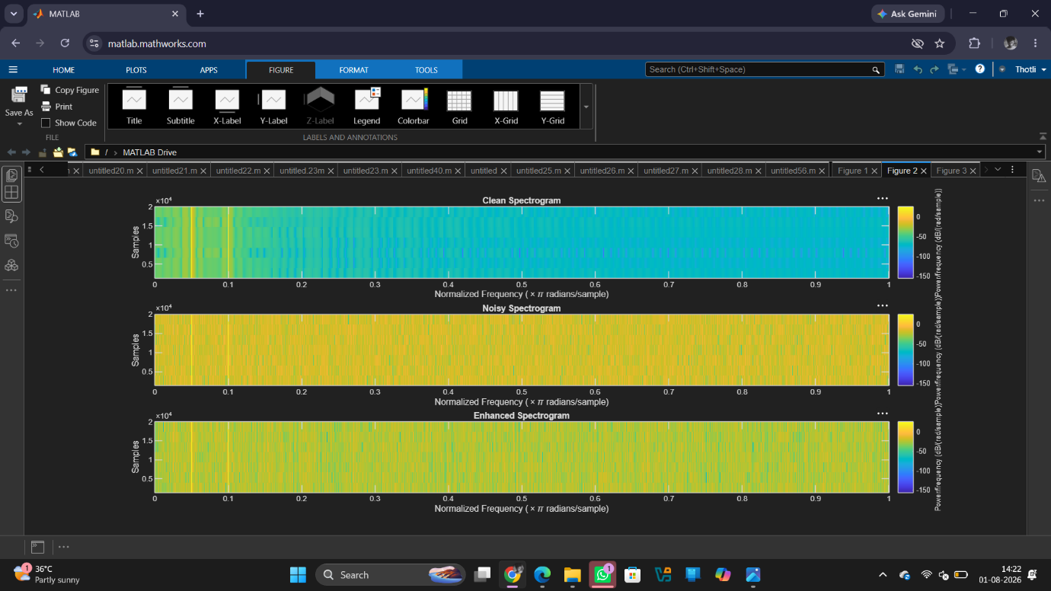

Fig 3
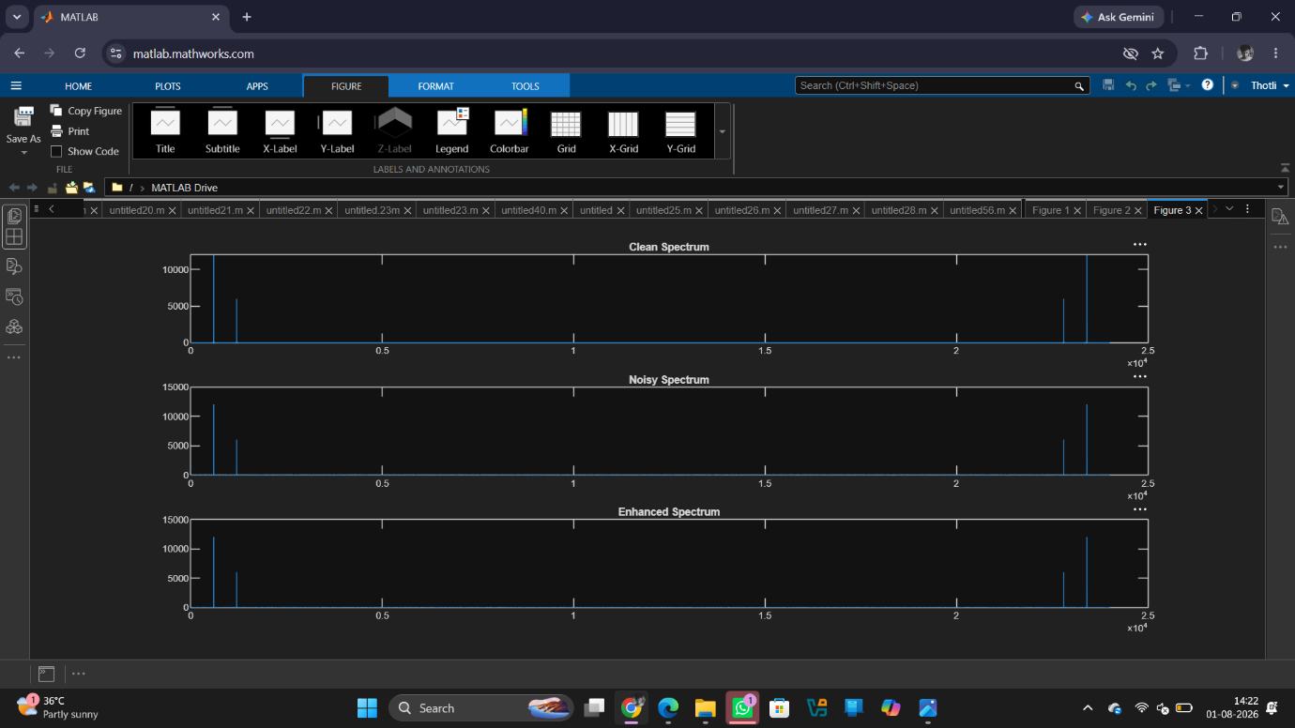
Result
1. A noisy speech signal was successfully generated by adding noise to the clean speech signal.
2. The noise spectrum was estimated and the Spectral Subtraction algorithm was successfully implemented.
3. The magnitude spectra of the noisy and enhanced speech signals were obtained and analysed, showing a reduction in noise components after enhancement.
4. The performance of spectral subtraction was evaluated, and the enhanced speech signal exhibited improved speech quality and intelligibility compared to the noisy speech signal.

